RTL Circuits: NOT GATE
Overview:
This invertor circuit takes an input of either a “HIGH” or “LOW” signal and flips it. The logic circuit is constructed using a combination of transistors and resistors.

Equipment:
- 10kΩ and 1kΩ resistor
- 2N3904 BJT
- LED
- 5V Linear Breadboard Supply (details in README)

Schematic:
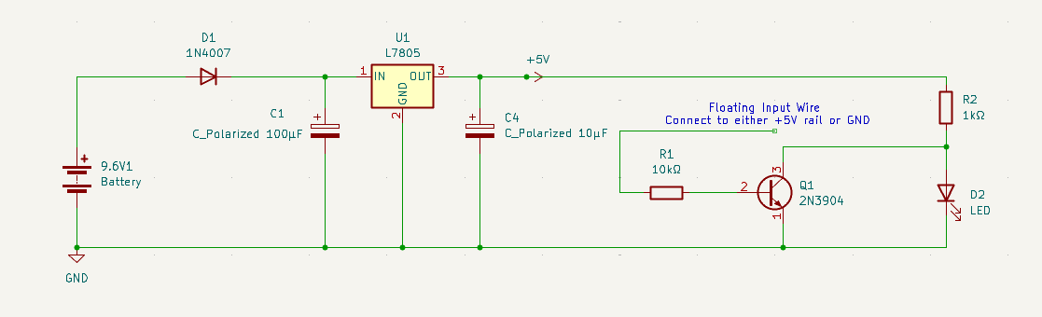
Figure 1: NOT Gate circuit schematic connected to linear power supply

Truth Table:
Input (X) | Output (Y)
0 | 1
1 | 0

Circuit Operation:
The floating wire input connected to the base of the 2N3904 BJT can be connected alternately between the +5V rail (logic “HIGH”, “1”) and GND (logic “ZERO”, “0”).
As we have the emitter as our shared reference point, this circuit can be simplified into a common emitter switch.
Theoretically, when our input wire is connected to:
- 5V Rail (Logic 1)
$$I_{B}=\frac{V_{CC}-V_{BE}}{R_{B}}$$“$V_{BE}$”, which is the voltage drop across the base-emitter junction, for a 2N3904 BJT, it is usually set at 0.7V. “$V_{CC}$”, which is our 5V from the power rail, and “$R_{B}$”, which is our input resistance to the base of the transistor, 10kΩ. Hence our expected “$I_{B}$” is 430μA.
$$I_{C\left(sat\right)}=\frac{V_{CC}-V_{CE\left(sat\right)}}{R_{C}}$$
To calculate the saturation current, we can calculate the collector current when the transistor acts as a short circuit, assuming it to be ideal, hence “$V_{CE\left(sat\right)}$” is 0V. In this case, “$V_{CC}$”, which is our 5V from the power rail, and “$R_{C}$”, which is collector pull-up resistor of the transistor, 1kΩ. Hence “$I_{C\left(sat\right)}$” is 5mA.
To verify this BJT’s operation, we can calculate the Forced Beta ($β_{forced}$) by dividing the collector current by the base current, which is approximately 11.63. This is massively smaller than the natural minimum beta ($h_{FE}$) of 2N3904 transistors, and so it was forced into saturation. The LED is off.
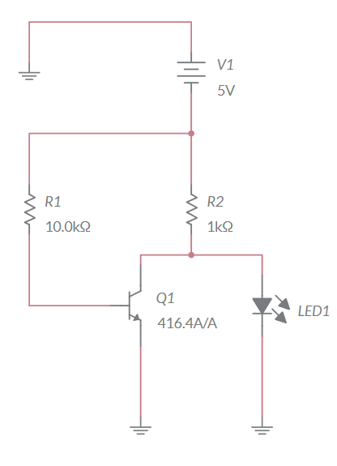
Figure 2: NOT gate with Logic 1 input
- GND (Logic 0)
When our input wire is connected to GND, there is no input voltage at the base, hence “$I_{B}$” is 0A. To allow current to flow, the voltage drop across the base-emitter junction must be 0.7V. As this is not the case, the threshold is not overcome, hence the transistor is off, operating in cut-off.
As a result, no current can flow through the collector of the transistor. Hence, current must flow through the collector pull-up resistor and directly to the load, in this case, an LED.
An unloaded output should sit at 5V. Due to the presence of the LED, a portion of the 5V is taken for the LED forward voltage, which varies depending on the colour of the LED.
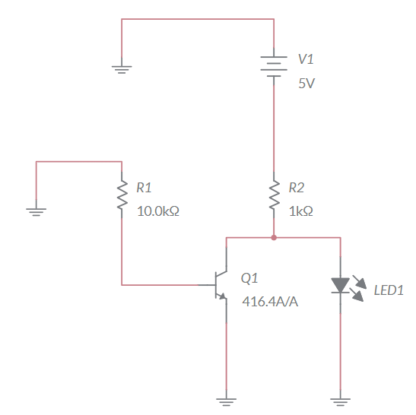
Figure 3: Not gate with Logic 0 input

Experimental Measurements
- Base-Emitter Activation: The base-emitter voltage drop required to forward-bias the transistor was measured at 0.717V closely aligning with the theoretical 0.7V.
- Logic 0 Output (Saturation): With a 5V input, the transistor successfully entered hard saturation. However, a physical BJT is never a mathematically perfect short circuit. The measured output voltage was 44mV, proving the gate successfully choked the load current while sinking the remainder to ground.
- Logic 1 Output (Diode Clamping): With a 0V input, the transistor successfully entered cut-off. Instead of the theoretical unloaded 5V, the output clamped at 2.64V. This is due to the physical load; the wide-bandgap semiconductor material of the blue LED dictates a high forward voltage drop to generate photons, pulling the collector voltage down. This reading changed to about 1.82V with a red LED.

